**Project Planning Phase**

**Project Planning Template (Product Backlog, Sprint Planning, Stories, Storypoints)**

|  |  |
| --- | --- |
| Date | 21 October 2022 |
| Team ID | PNT2022TMID40335 |
| Project Name | Retail Inventory Management System |
| Maximum Marks | 8 Marks |

**Product Backlog, Sprint Schedule, and Estimation (4 Marks)**

Use the below template to create product backlog and sprint schedule

|  |  |  |  |  |  |  |
| --- | --- | --- | --- | --- | --- | --- |
| **Sprint** | **Functional**  **Requirement (Epic)** | **User**  **Story**  **Number** | **User Story / Task** | **Story Points** | **Priority** | **Team Members** |
| Sprint-1 | Registration | USN-1 | As a user, I can register for the application by entering my email, password, and confirming my password.. | 2 | High | Ramya  Shofica |
| Sprint-1 | Registration | USN-2 | As a user, I can register for the application through E-mail | 1 | High | Kamali V |
| Sprint-2 | Registration | USN-3 | As a user, I will receive confirmation email once I have registered for the application | 2 | Low | Nisha R  Kamali V |
| Sprint-2 | Registration | USN-4 | As a user, I can log into the application by entering email & password | 2 | Low | Shofica L  Ramya S |
| Sprint-1 | Registration | USN-5 | As a user, I can view the products which are available | 2 | Medium | Nisha R  Kamali V |
| Sprint-1 | Login | USN-6 | As a user, I can add the products I wish to buy to the carts | 1 | High | Ramya S |
| Sprint-3 | Dashboard | USN-7 | As a user, I can add products which are not available in the dashboard to the stock list | 1 | Low | Nisha R |
| Sprint-3 | Dashboard | USN-8 | As a user, I can contact the  Customer Care Executive and request any services I want from the customer care | 1 | High | Shofica L |
| Sprint-3 | Dashboard | USN-9 | I can be able to report any  difficulties I experience as a report | 2 | High | Ramya S  Shofica L |
| Sprint-4 | Dashboard | USN-10 | As a user, I can able to see the Nearby cheap, and Quality products | 1 | Low | Nisha R |
| Sprint-4 | Management | USN-11 | As a Administrator, I will update our web application with additional features. | 2 | Low | Shofica L  Nisha R |
| Sprint-4 | Management | USN-12 | As a Administrator, I can maintain third party Services | 1 | High | Ramya S |

**AV (Total) = 24/24 = 1**

**Project Tracker, Velocity & Burndown Chart: (4 Marks)**

|  |  |  |  |  |  |  |
| --- | --- | --- | --- | --- | --- | --- |
| **Sprint** | **Total**  **Story**  **Points** | **Duration** | **Sprint Start Date** | **Sprint End**  **Date (Planned)** | **Story Points**  **Completed (as on**  **Planned End Date)** | **Sprint Release Date (Actual)** |
| Sprint-1 | 6 | 6 Days | 24 Oct 2022 | 29 Oct 2022 | 6 | 29 Oct 2022 |
| Sprint-2 | 6 | 6 Days | 31 Oct 2022 | 05 Nov 2022 | 6 | 05 Nov 2022 |
| Sprint-3 | 6 | 6 Days | 07 Nov 2022 | 12 Nov 2022 | 5 | 12 Nov 2022 |
| Sprint-4 | 6 | 6 Days | 14 Nov 2022 | 19 Nov 2022 | 6 | 19 Nov 2022 |

**Velocity:**

Imagine we have a 10-day sprint duration, and the velocity of the team is 20 (points per sprint). Let’s calculate the team’s average velocity (AV) per iteration unit (story points per day)

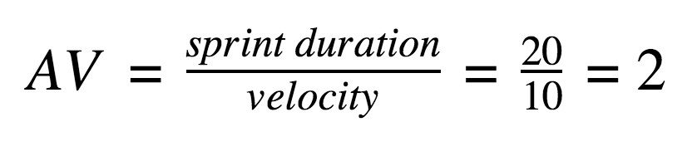

**AV (Sprint 1) = 6/6 = 1**

**AV (Sprint 2) = 6/6 = 1**

**AV (Sprint 3) = 6/6 = 1**

**AV (Sprint 4) = 6/6 = 1**

**Burndown Chart:**

A burn down chart is a graphical representation of work left to do versus time. It is often used in agile[software development](https://www.visual-paradigm.com/scrum/what-is-agile-software-development/) methodologies such as [Scrum](https://www.visual-paradigm.com/scrum/scrum-in-3-minutes/). However, burn down charts can be applied to any project containing measurable progress over time.

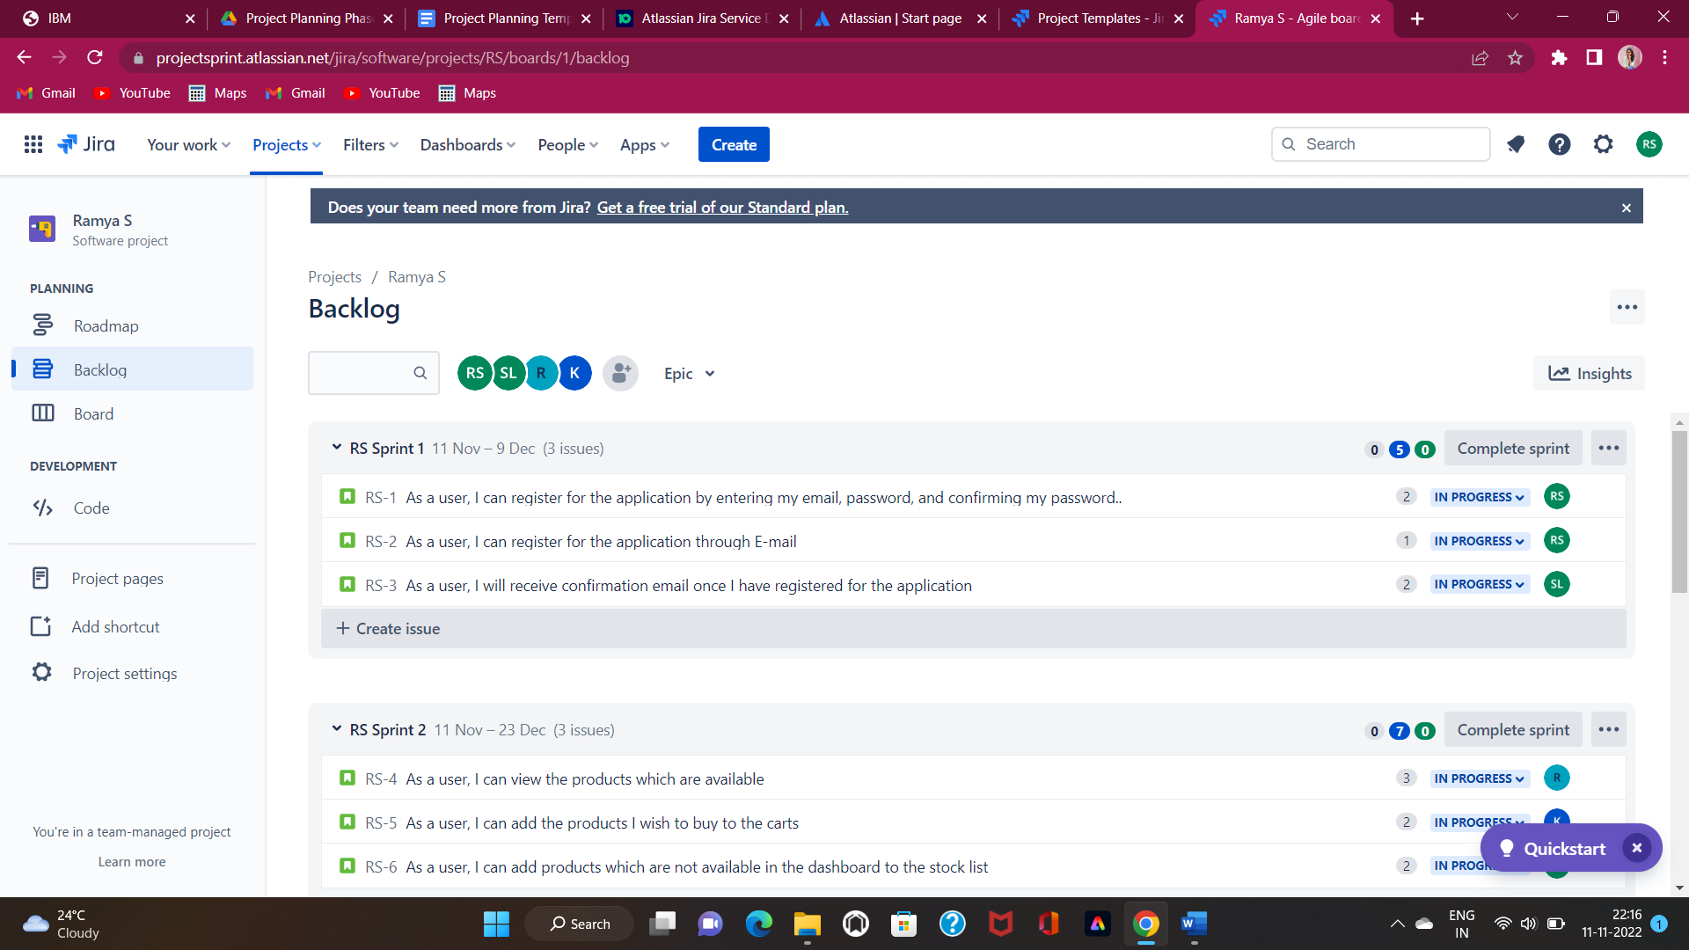

[**https://www.visual-paradigm.com/scrum/scrum-burndown-chart/**](https://www.visual-paradigm.com/scrum/scrum-burndown-chart/)

[**https://www.atlassian.com/agile/tutorials/burndown-charts**](https://www.atlassian.com/agile/tutorials/burndown-charts)

**Reference:**

[**https://www.atlassian.com/agile/project-management**](https://www.atlassian.com/agile/project-management)

[**https://www.atlassian.com/agile/tutorials/how-to-do-scrum-with-jira-software**](https://www.atlassian.com/agile/tutorials/how-to-do-scrum-with-jira-software)

[**https://www.atlassian.com/agile/tutorials/epics**](https://www.atlassian.com/agile/tutorials/epics)

[**https://www.atlassian.com/agile/tutorials/sprints**](https://www.atlassian.com/agile/tutorials/sprints)

[**https://www.atlassian.com/agile/project-management/estimation**](https://www.atlassian.com/agile/project-management/estimation)

[**https://www.atlassian.com/agile/tutorials/burndown-charts**](https://www.atlassian.com/agile/tutorials/burndown-charts)